

**Game Concept Document**

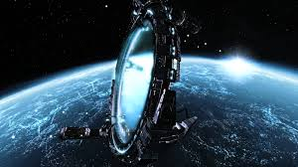

Written by: Michael Lojkovic and Alex Lueck

Version : 00.01

Date: 4 / 30 / 2014

**Table OF CONTENTS**

Premise

DESCRIPTION

FEATURES

GENRE

PLATFORM

ESRB RATING

TARGET MARKET

MARKETING POSITION

COMPETITIVE ANALYSIS

BACKSTORY

RISK ANALYSIS

SUMMARY

# 

# **Premise**

Dym, a cyborg and last of his kind, must protect the universe from the baron and his army led by the dark priests of the outer rim or else destruction of the universe is assured. The player uses Dym’s arsenal of weapons and ability to control time to make his final stand.

Dym is a sovereign of time. Dym is the last of this once great race, the last of his kind. Dym stands in the ruins of humanity, watching as enemies pour through a chaos chasm and enter this dimension, bringing further chaos. Dym will use ANYTHING AND ANYONE TO ENSURE THAT peace, and his lineage will go on.

# **Description**

Its Dym’s task, as the Sovereign of time, is to keep the peaceful balance of time through the ages. Dym’s ancient race was responsible for keeping the universe balanced and on course for functioning in harmony. The dark priests overtook his people’s citadel, while he and a few other were out on a routine patrol of the sector. Bringing his once mighty race to an end. Before the dark priests could land the final blow, though, his people managed to activate their last remaining hope banishing them back to their homeland in the outer rim. Now, they make every effort possible to return through chaos chasms to the inner rim systems. Since then Dym has increased his vigil over the universe ensuring that neither his people nor the forces of the dark priests come back through.

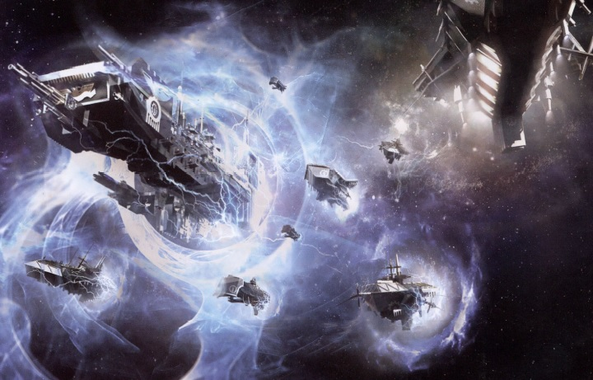

The player joins Dym as he has tracked the baron to one of his mining stations in the outer rim. While there a chaos chasm opens up, and forces of the dark priest’s army begin coming through. It is Dym’s responsibility to send anything back that might come through and shut the chasm. During this inspection Dym learns about a force in his universe that may have made a pact with the dark priests. With this pact they are able to open the chaos chasms for personal gain and universal dominance.

In order to accomplish the task of shutting the CHASM FOR GOOD, and investigating those responsible for reactivating them the player has to use Dym’s many powers to accomplish his task. Dym’s greatest weapon is his ability to control time. Dym, when his time meter is full, may use various abilities that drain it at different rates. These abilities include the ability to slow time, and completely stop time all together for his foes. During this period he may maneuver till he gains the upper hand in battle and deliver devastating ATTACKS AND COUNTERS. As the adventure continues he unlocks additional time manipulation abilities.

Not only can he control time, but he also has a vast array of weapons, armors, attacks, and combos at his disposal. Through drops and shops he unlocks new weapons and armors to use in his quest. These weapons modify the type of offensive and defensive abilities he has, and as he uses their different attacks and abilities, he levels them making them stronger. Based on which attacks and abilities he has leveled new attacks, abilities, and combos will unlock for each weapon.

On top of the leveling of weapons the player also has 3 skill trees to traverse that modify how the character plays. These skill trees mostly provide passive modifiers, but also unlock the ability to use that trees weapon specialization, and provide new abilities for Dym to use.

Dym’s active defensive capabilities take advantage of the 2D brawler, like platforming setting. Dym is constrained to moving on one plane at time, but may jump between at least 2 other 2D planes for exploration, and dealing with threats. Dym can use these plays in a defensive manner by pressing the dodge key, which bobs and weaves him out of the enemies strike radius, only to return for a quick counter attack.

The interface and view of the world supports the games feel and play style. The interface consists of Dym’s health and power gauges for relaying the current state Dym is in. The view of the game world is either 2D or 3D, but has a viewing angle typical of a brawler. The main idea behind the view is keeping the player aware of the events on screen, while also allowing him to easily and quickly tell which planes are available for traversing. Beyond the view the gameplay resembles a MetroidVania with vast maps to explore, and new things to find in old areas as the gameplay progresses. In terms of development we will build up to the MetroidVania aspect as time goes one, by at first just making a good platformer / brawler and then adding new features in when appropriate and rebalancing the old.

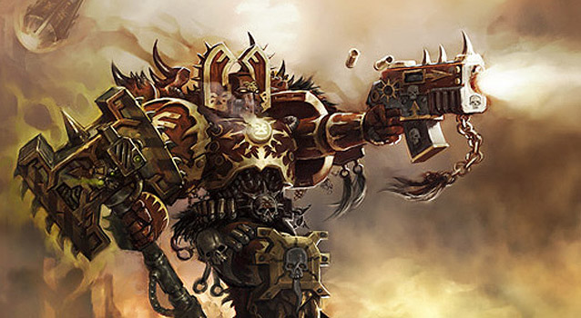

The actual setting of the world is Sci-Fi noir, with hints of space opera. A rather drab color palette will support this setting, with mystical creatures and mysterious powers reinforcing the space opera elements. Think of the world’s look as a combination of Alien, Blade Runner, and Warhammer 40k. Dym’s people will be much like the Elves or one of the ancient race from 40k, while the Forces of Oblivion are the forces of chaos / ancient evils present in that world. Those two factions set the background and ancient history of the world, while the modern day people only knows about them through legends and tales. Basically, they only have remnants of the world past that occasionally seep through, so the modern people have more mechanized and impure technology, while the older races have advanced pure technology with almost a magical tinge to them.

Dym gets to explore the decrepit cityscapes of modern day man with their flame belching structures and smoke stacks. Modern man is technologically advanced, but their look and feel is that of do it yourself projects that have been hobbled together by spare parts. The main key in the look is keeping the ancient races looking pure, whether light or dark, but keeping the modern people corrupt and barely scraping out a living in their design.

By the end of the journey Dym will find, which dark forces are responsible for summoning the forces of Oblivion back, and learn the final fate of his people. The further the player gets the greater his sense of power, and investment in discovering the mystery present in this Sci Fi adventure. The player will love the complexity of play, and how the lore connects to supporting this play. The player will wish the grand journey provided by the game will continue on without end.

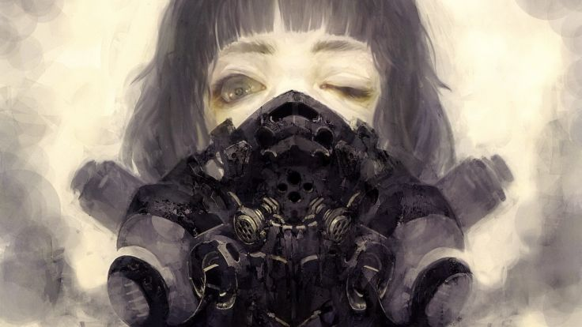

# 

# **Features**

* Vast world filled with mystery and different ages of technology to explore.
* Control the flows of time.
* Unique perspective on 2D game play.
* Customize your character as you progress.
* Level various weapons based on use.
* Massive bosses.
* Interact with merchants to expand your collection of weapons and armors
* Unforgiving, but fair difficulty.
* The action always remains fast paced.
* Skill Trees

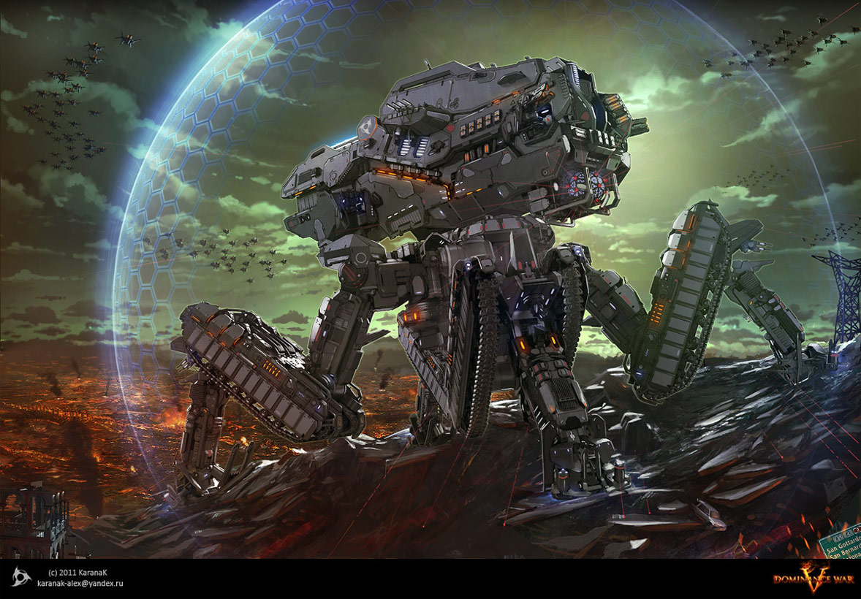

# **Genre**

A 2D platformer / brawler RPG that breaks from the single plane present in past MetroidVanias. Dym adds an extra level of exploration to an already exploration driven genre by adding additional planes of movement. Having these extra planes opens up combat options, and the placement of paths through each area. This allows us to have areas in the background Dym can only access from one plane, and use these to change the state of other planes, for when he travels back there through one of the other routes.

The RPG element allow various play styles and also increases the depth of the combat system present in our game. The key aspect is using the leveling to empower the player, but not make him so powerful that merely grinding will be enough for him to advance. Rather gaining levels unlocks different options and means for dispatching the foes he encounters.

# **Platform**

All platforms, but development will target the PC first. The PC makes sense for the initial target from low barriers to entry, and the very large market currently present on it compared to other platforms. Consoles make sense too, and need to be considered during development of the game. We’ll be using Unity to develop, at least initially so platform compatibility shouldn’t be too much of an issue, but if we can switch over to using our own engine at some point that would be preferable, though support for the different platforms at the base of the code would need to be considered then. We could use MonoGame for accomplishing this or a homemade engine.

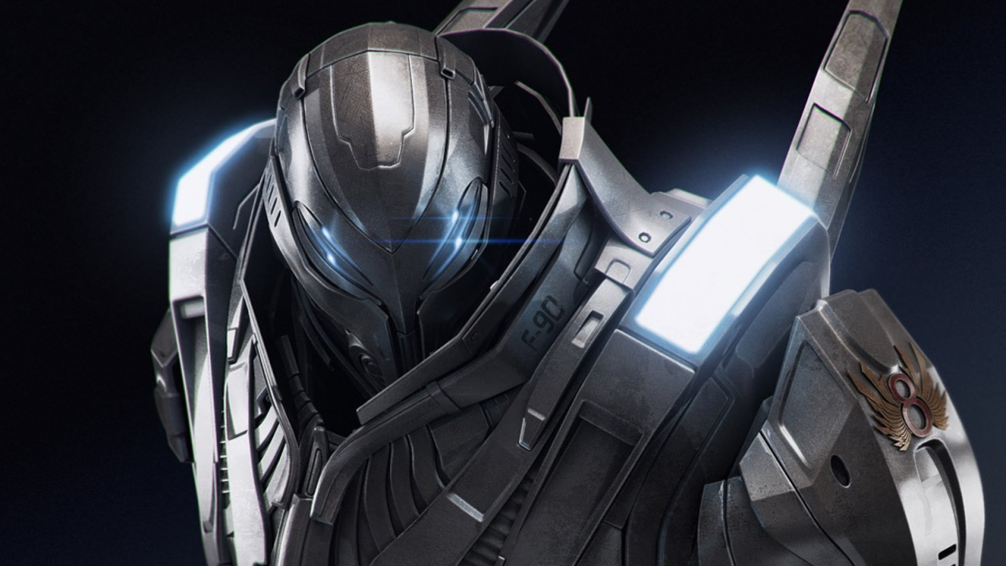

# **ESrb rating**

Teen to Mature. Ratings at this level will allow us to go into the themes we wish to address, and people in those age groups are our target market.

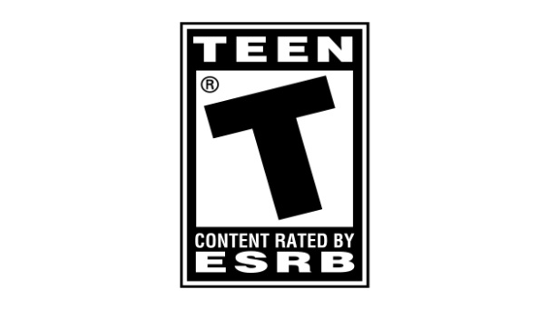

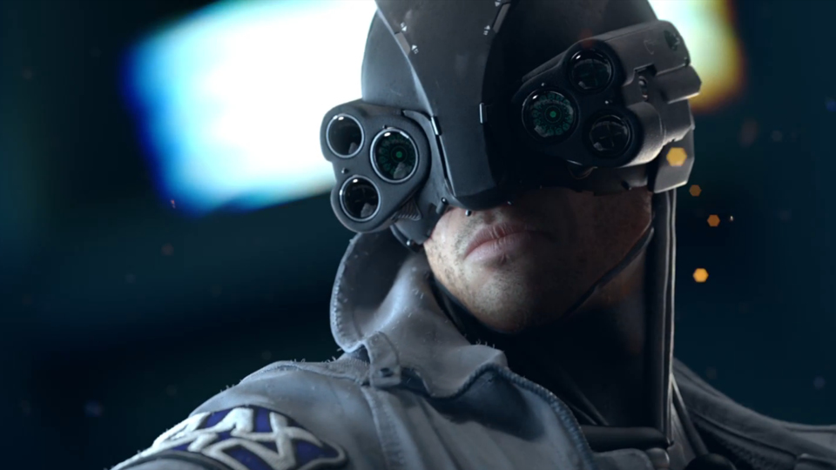

# **Target Market**

The market for the game consists of mostly teenagers to males into their 30’s. We’ll be drawing on the same crowd that has played MetroidVania’s in the past, and also those who like Sci Fi, like Blade Runner and Warhammer 40k. This game matches up with all of the categories this market would love to see in a game.

# **Marketing POSITION**

Our main marketing position is the unique take additional planes offer for a MetroidVania, the combat system, and lore of the world. MetroidVanias have long been locked to one plane of exploration with only the occasional interaction with the background and foreground. Our game will offer the player full access to at least these two additional planes. The complexities the combat system offers will reinforce the mechanics present with the other planes, making the player enjoy his ability to take advantage of the 2 other planes in times of intense battle. The lore brings the whole world together grounding the player in it. This offers him an interesting world to explore that is a combination of old and new, and technologies of different styles. He’ll feel amazement with the contrast of star age technology against high technology with the impurities of the start of the industrial age.

# **COMPETITIVE ANALYSIS**

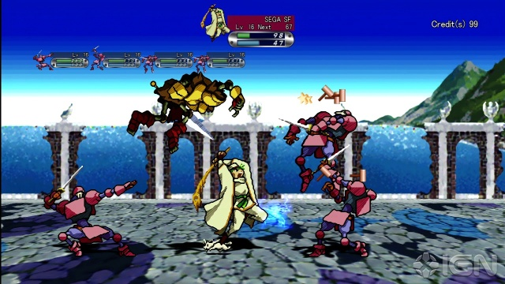

Guardian Heroes could be considered a competitor since it uses a similar plane mechanic. In Guardian Heroes the player plays as an adventurer going through an adventure that can spiral off into multiple vastly different paths and vastly different stories revolving around the same theme. Dym will attract the same audience as this game through a similar plane switching mechanic and a vast world to explore. While Dym won’t be played through as much to see all of the different content, all of the content can be seen through one play through though be it a longer playthrough. This increased play length allows us to provide additional variety in terms of how Dym can engage the enemies, offering the same depth as Guardian Heroes through a different feel.

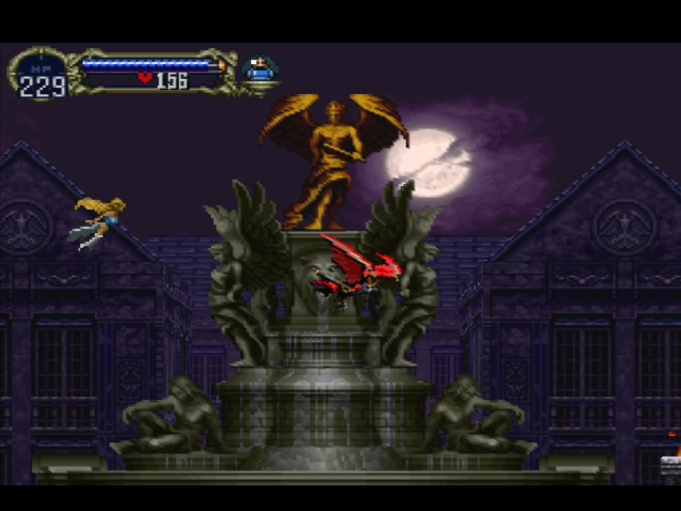

The latest Castlevania, in the style of a MetroidVania. Games like Castlevania Symphony of the Night provide the player with a vast world to explore and a character to adopt to his preferred play style in that world. The CSN series is a great example of a game that uses action and RPG mechanics to deepen the player’s exploration and interaction with the game world. One thing CSN often gets wrong is allowing the player to beat bosses just by leveling his character further. We seek to address this by either capping the character’s max level allowed until defeating a boss or having bosses scale with the player’s current level. This allows us to give the player an experience that remains challenging without allowing the player to level out of the feeling successfully completing challenging content gives him. We also have an interesting world to explore.

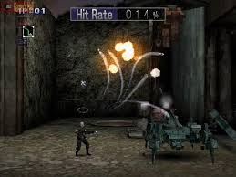

The latest Contra. Contra captures the frantic pace of combat we are hoping for. Contra attracts a player that wants challenge, and also provides interesting enemies and massive bosses for the player to fight against. The fact that the player always needs to be moving to dodge wave upon wave of enemy and adjust their strategy against the various enemies is what gives it a challenging feel. In order to capture this same market seeking challenging gameplay we need to change up how the challenge works a bit. We’ll create the same sense of challenge, but adjust it so the player has to think more about which attack he will use rather than just holding one button down the entire time. By requiring the player to select his specific actions we will be able to engage the same market as Contra, by providing them a slightly different combat experience.

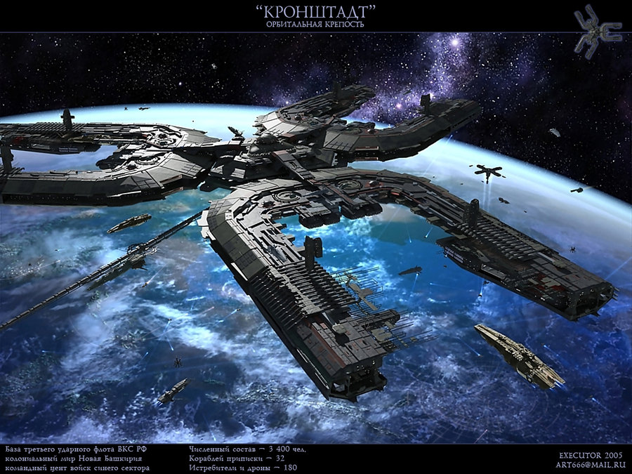

# **backstory**

It’s Dym’s task, as the last of Warp Defenders, to protect the Warp Gates from the forces of Oblivion. Dym’s ancient race was responsible for keeping the universe balanced and on course for functioning in harmony. The Oblivion Forces overtook his people’s citadel, while he was out on a routine inspection bringing his once mighty race to an end. Before the forces of Oblivion could land the final blow, though, his people managed to activate their last remaining hope banishing them deep within the Warp to the Dark Universe.

Now, they make every effort possible to return through the Warp to the Light Universe. Since then Dym has increased his vigil over the Warp Gates ensuring that neither his people nor the forces of Oblivion comes back through.

The game picks up with Dym surveying the active Warp Gates in the Light Universe, thousands of years in the future, from his command center, when he notices some strange readings from one of the Gates on an industrial planet. Dym heads out to that planet to investigate the events, and make sure that gate doesn’t go online, and if it does shut it down for good. During his investigation he’ll get to know the massive city of the planet and come to see how the members of the city have been manipulated into reactivating the gate.

# **risk ANALYSIS**

Creating a MetroidVania is substantial undertaking. We’ll have to spend months developing Dym’s abilities and making test levels to test those abilities out on and the enemies he engages, before we can even design the levels. A positive of this is if production on Abilities is taking too long to create the complex world of a MetroidVania, we can always scale back our scope and use those same abilities in a 2D brawler / platformer setting.

Animating the transition from one plane to a next seems like it could take work. We’ll need a way for the animation to know how to move the character between planes, and then have the code snap him to the current plane. The dodge mechanic needs to animate the sprite so it looks like the sprite bends the top portion out of the current plane into an adjacent plane, and then pulls the lower portion out as the top portion moves back. Not really sure how to do this, but the artist will have to figure this out.

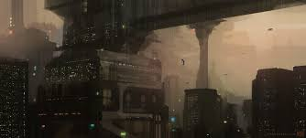

# 

# **Summary**

Dym will take the MetroidVania genre and innovate upon it. Innovation comes from us taking features present in a few other critically acclaimed games and mashing them together to create a new experience, which the totality of the player has not seen yet. Dym’s fast paced nature gives the MetroidVania genre a different more Contra like feel, while keeping the old tropes of the genre alive. The plane switching deepens the level of exploration the genre already provides allowing the player to see more, and go into the background that until now has just been backdrops. Dym provides the player with enough of the old to keep the experience familiar, while breathing new life into old ideas.